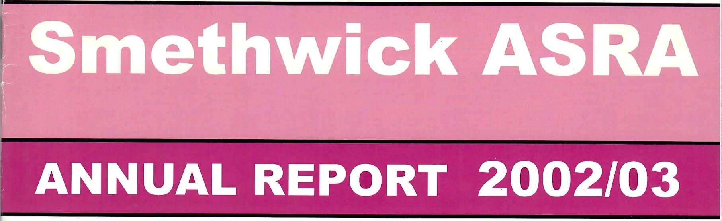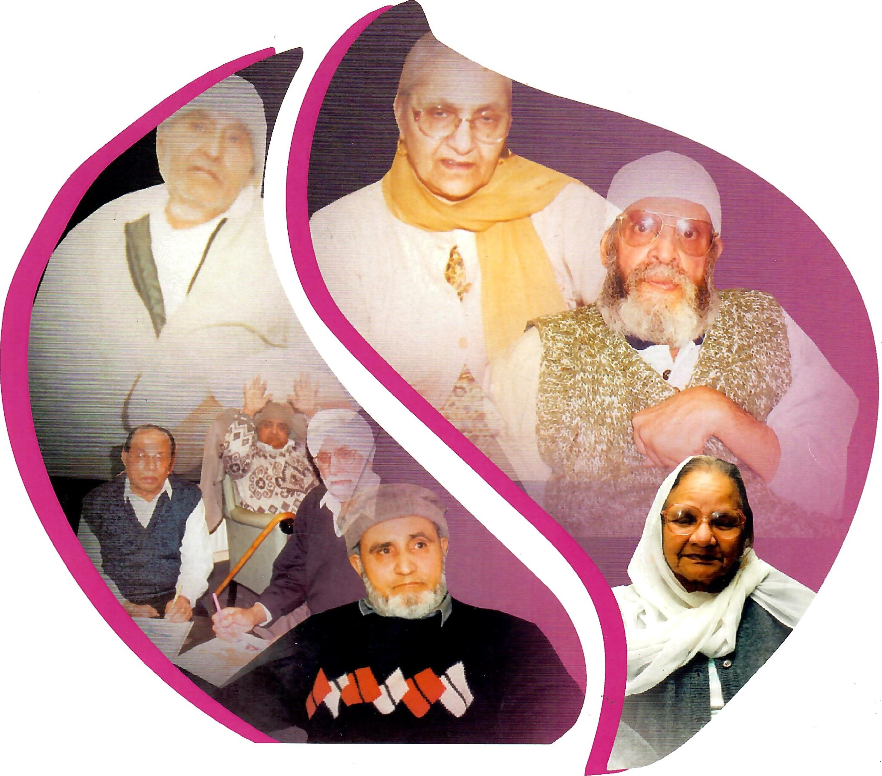

SMETHWICK ASRA

ANNUAL REVIEW/REPORT

2002/2003

"One of the greatest opportunities that face us this century is to respond to the need of our ageing population and to harness effectively the contributions older people can and no make to society."

Prime Minister Tony Blair

CONTENT

Page

Mission Statement 1

Annual Review 2

Jewels in the Crown 7

First Arrivals — Today's Elderly 9

Smethwick ASRA — The Organisation 1 1

Legal & Administrative Information

Other Agencies/Services

Sandwell Asian Family Support Services (SAFSS) 20

Primary Care Trust 21

Rehabilitation Team

Chiropody Service 22

Black Country Multiple Sclerosis Team 22

Asian Women's Health Initiative (AKASH) 23

Financial Information 24

## MISSION STATEMENT

We are committed to the provision of appropriate housing and care services for all the South Asian elderly, disabled and families.

|  |
| --- |
| Annual Review |
|  |
| Asra's Chairman, Dr Vinny Jhanjee and Projects Director, Javed Parvez, review 2002-2003 |
|  |

2002 was another challenging year for Asra. However, given where we started the year, we have made real progress in the face of an exceptionally adverse financial climate.

Our biggest achievement for the year was to turn a certain deficit situation into a small surplus. Had we been allowed to make progress at that speed and not had a cut of nearly £65,000 in our funding by Sandwell Council, the list of our achievements would have been much longer.

While it has been a tough year we have held together and worked to become a strong and successful organisation. However, we still have some way to go to achieve the service levels we had originally planned. We have continued to evolve new ideas and develop new initiatives and explore new partnership projects.

Good progress has been made to reduce some of the uncertainty at the start of the year. We have set out clear business objectives, Stabilise the income streams and explore new income resources, reduce expenses and restore an efficient business operation. This has enabled us to move the organisation towards safer, more stable grounds and ensure that we could meet our financial/contractual obligations.

Throughout the year, having defined our objectives and mapped our way forward all energies have been concentrated on looking inwards and developing ourselves into best possible shape to face the challenges ahead. Earlier in the year we embarked on a process of strategic planning which involved areas of governance: regulatory issues, vision, growth, operations, people and marketing. We were successful in establishing the key areas that we need to address in formulating a strategy for the future.

In making the commitment to become a quality led organisation, greater responsibility has been placed in the Management Committee in relation to the governance of Asra. This work we will continue to develop in terms of operational structure and responsibilities of executive officers over the next financial year and beyond. Part of this work has already started. The Asra Board will review the key areas on regular intervals.

We are pleased to report the production of our business plan for the next five years. This is a robust document and one that spells out the work of the organisation and the position we expect it to reach.

Over the years, we have successfully designed tailored and delivered user centred and needs led services and provided them in a way which our client groups greatly appreciate. At a time when no such services existed, Our new Health and Social Care Centre is a prime example.

However, our sense of achievement is qualified by the continuous concern about the inexorable growth in the field of post hospitalisation care of Asian elderly and disable. Current provision offered by Asra is going to be insufficient to keep pace with the growing demand.

For the future we are seeking to increase the level of services. We are keen to extend our expertise of providing culturally appropriate social care/rehabilitation services and have been involved in expanding our services not only in Sandwell but also in Birmingham and Dudley.

Asra's future diversification and planned development will require both capital and revenue expenditure. We are confident that with our track record we shall be able to obtain/secure both. We shall be seizing the opportunities that may be open to us.

We look towards a positive future and despite some of the challenges of the past, a renewed partnership working with Sandwell Council as we believe we can truly make a difference and assist/enable the statutory agencies to plan and deliver services to the Asian elderly and disabled. Our sincerest thanks to everyone who has helped and assisted Asra, to our Committee Members, our staff, volunteers and trainees who have provided invaluable support and commitment during the year.

Our thanks also go to Harborne Parish Lands Charity and Henry Smith Charity for their financial support. Hopefully we would like to add Sandwell Council to our list of funders for 2003-4.

Furthermore, our biggest thanks goes to the drop-in service users who have continued to support Asra despite losing Saturday and Sunday sessions due to cuts in grants from Sandwell council.

Finally, we would like to record our gratitude to Amrik Nagra and his team (Nagra Builders) for building our extension, decorating our centre, and providing ongoing regular and emergency maintenance cover at very charitable rates.

We look forward with optimism to the coming year.

Jewels in the Crown:

### Contribution of ethnic minorities in Post-War Britain

Britain in the 21st Century is a nation that has been built on the foundations of cultural diversity brought by centuries of migrants arriving on our shores. Despite the current perception held by many that immigration is a modem issue, the influence of cultures from overseas is well documented and an integral part of the fabric of this country.

When the topic of immigration is raised, most people think of post-war migration from the Commonwealth, chiefly the Caribbean and the Indian sub-continent. However, Black and Asian migrants have been settling in the UK for more than 300 years.

There is resistance and opposition to immigration. Ignorance of other cultures and the benefits of immigration causes many in Britain to oppose it. Immigrants are often seen as problems or causes of problems. Yet a closer look reveals a very different picture — contrary to causing problems, immigrants offer the potential to solve problems and enrich both our culture and our way of life. People from ethnic groups now play crucial roles in many different areas of our lives, from business to medicine.

The first of the modem immigrants came in the early 1950s as Britain struggled to rebuild its post-war economy and re-establish itself on the world stage. A chronic shortage of labour in particular economic sectors saw employers look overseas to recruit workers. Initially this focussed on Irish and other immigrant groups, such as the Italians and the Poles. However, it was soon clear that these sources could not fulfil demand alone and so the Government turned to its Commonwealth as a source of manpower.

Many of the first migrants from the Caribbean came as a result of recruitment missions to their home countries by employers such as the National Health Service, London Transport and the British Hotels and

Restaurants Association. They were soon followed by migrants from the Indian sub-continent, initially India and then latterly Pakistan and Bangladesh.

These immigrants took up jobs that white British people no longer wanted; hard manual labour or jobs with difficult working conditions. They diffused out from the initial points of entry to take jobs in expanding industries such as the car plants of the Midlands and the textile mills of the North. The areas in which they settled form the basis for the well-established ethnic communities we see in Britain today.

Although welcomed at first, by the mid-1950s immigrants were the focus of racially motivated violence and had been branded a cause of social decline.

Ethnic communities have also been largely responsible for the about turn in prosperity in many inner city and urban areas over the past decade. By the mid-70s, many white British people were leaving the city and urban areas for more attractive suburban and semi-rural areas. This followed the pattern of white people moving from blue-collar jobs to better paid and more prestigious white-collar and clerical positions.

In the same way that the new immigrants took up the jobs the white population no longer wanted, they also took over the neighbourhoods that were abandoned. These areas, populated only by the poor and the elderly, had deteriorated through a lack of investment. Homes were decaying, businesses had moved out and shops had shut. Ethnic communities began to bring life and vitality back to these areas, investing in both their homes and in local businesses. Local economies were transformed.

This pattern was repeated within certain areas of commerce, for example the garment industry. When Asian immigrants arrived in the UK in the 1950s, many took up positions in the clothing factories in the North primarily because nobody else wanted these unsociable, poorly paid jobs. However, after foreign competition had decimated much of this industry in the 60s and 70s, it was Asian entrepreneurs who breathed new life back into it, by establishing a whole new and complex network of Asian owned clothing manufacturers, suppliers and wholesalers.

In addition to returning prosperity to many parts of the North, and providing numerous jobs, the revitalised textile industry helped establish ethnic groups as skilled and respected business leaders. In an echo of the Jewish immigrants who created the likes of Marks & Spencer and Burton, the Asian-owned clothing manufacturer, Joe Bloggs, grew to become a household name.

Service sectors have also come to depend on Asian and Black Caribbean workers for their survival. The National Health Service, one of the pioneer employers of immigrants, has a large number of ethnic professionals on its medical and nursing staff. In many areas of health care, especially the less popular areas of medicine, such as psychiatry and geriatrics, ethnic doctors and nurses are in the majority and form the backbone of the service.

This picture of hard work and skill is repeated throughout commerce, with ethnic workers being successful employees. (Asian men are much more likely to hold clerical positions than white men), and dynamic entrepreneurs running businesses that range from retail and catering through to distribution.

The next generation of ethnic groups are also preparing for a successful life and career, with more Black and Asian pupils staying at school and consequently becoming more qualified than their white counterparts.

In the arts and sports too, Black and Asian people are becoming successful on both the national and international stages. Many of Britain's top athletes, boxers and footballers are Black, providing role models for young whites and blacks alike, and promoting a new multicultural image for Britain abroad.

Britain's ethnic minorities are an important part of our country. Their settlement in the UK provides us all with an opportunity, rather than a problem that must be solved. To seize that opportunity and to ensure that modem immigrants play the same important role in our future as other migrants have in our past, we must recognise their worth and change our perceptions now.

Dr Vaughan Robinson, University of Wales

FIRST ARRIVALS - TODAY'S ELDERY

THEIR EXPERIENCES & STRUGGLES

I would like to start by telling you a story from the Fifties about the experiences of one of those earlier immigrants, from the Caribbean who faced racial discrimination in this country with such fortitude, grace and even good humour.

She recalls 'since I came here, I never met a single person who had any colour prejudice. Once I walked the whole length of a street, looking for a room and everyone told me that he or she had no prejudice against coloured people; it was a neighbour who was stupid.' She then reflects wryly, 'If you could only find the neighbour, we could solve the entire problem' — I think that's salutary.

I want, through this speech, to pay tribute to the determined struggles of people like her to climb out of the obscurity of a third-rate, second-class citizenship. The black and ethnic minority groups, have suffered a crisis of alienation, living in the inner cities of Britain and how they have struggled against racial prejudice, discrimination, harassment, intimidation, and of course even violence.

An overwhelming majority of migrants from Africa, Asia and the Caribbean came largely to work, with their hands, to join the labour force, to become part of the working class, just like the Irish had done before them to the big cities of England. They were brought here to serve a very specific economic function. Britain did not acquire its ethnic minority workforce, by default or by accident, or in a fit of an absence of mind.

Incidentally, there is a tendency for the English to constantly debate the issues of race as if it is a purely recent and brief, temporary encounter; as if they cannot understand how these poor ignorant people suddenly decided to pick themselves out of their villages and plantations and quite uninvited made this long strange and apparently unpredictable journey to the doors of Birmingham's factories and foundries, which as you know,

out of the goodness of their hearts gave them jobs. It is as if British attitudes to race, since the war, begin with a profound, historical forgetfulness, a kind of mental amnesia, and a decisive mental impression, which wipes out any trace of the colonial and imperial past. So, let me make an important observation about the past that Britain ignores; the appearance of a black proletariat in the heart of Britain's industrial regions was not an historical accident. All these immigrants from Guyana and Gujarat, from Bombay and Barbados did not just drop in on us from the skies. I therefore do not have to remind you how Britain's imperial dominance through the slave trade and indentured labour bound the fate of millions of workers and peasants, in the colonial hinterlands to destiny of the rich and poor in the heart land of the English cities. So even if the blood of colonial workers had not mingled with the English, then their labour power had long since entered the economic bloodstream of British society?

Now let me switch from looking at the historical to the contemporary. It can be said with some justification that the first generation of Britain's minority ethnic workforce inhabited a world markedly different from our own. They came to live in a society that was shaped by the depression of the 1930s, and the trauma of the Second World War. They lived through a period in which crude racism flourished unchecked; you know there used to be signs outside the doors, when I first came to Birmingham They said 'No Coloureds, No Irish, No dogs.' A racism that had been forged over many years, in the crucible of colonialism and imperialism of the British Empire. It mattered little to black people that this country had a reputation for justice and fair play, and prided itself in the system of parliament, a parliamentary democracy, that was thought to be the envy of the world.

Black people and colonial subjects settling here continued to suffer from prejudice and discrimination, at every level and in every sphere of their lives. However, one can now claim with some justification that we now live in a society that has been shaped by the inheritance of unprecedented freedoms. The freedom of social mobility, the freedom of education, the freedom of women to work, and the freedom to define one's own lifestyle. These freedoms have brought with it a spirit of optimism, a strong belief in autonomy, and a genuine relief at the disappearance of the rigid rules that governed previous generations.

Extracts from a speech by Ranjit Sondhi.

# SMETHWICK ASRA - THE ORGANISATION

Smethwick Asian Sheltered and Residential Association (ASRA) is a community organisation, a registered charity and private limited company. Asra was set up in 1984 by a group of professionals and lay people concerned about the difficulties being faced by the South Asian elders and disabled in Sandwell.

The organisation promotes the relief of poverty, hardship and distress by providing housing, homecare, day care and transport services to South Asian elders who are experiencing personal, social, health and family problems.

The primary objectives of ASRA are:

1. The relief of poverty, hardship and distress by providing and

Maintaining accommodation for elderly people (particularly

Elderly people of Asian origin or descent) residing in Smethwick and neighbourhoods thereof who are experiencing Personal housing and social difficulties.

1. The maintenance improvement and advancement of the

Vocational and occupational training of such elderly people.

1. To establish, furnish, alter, maintain and equip any residential accommodation including the management of such property whether principal or agent and also on behalf of a housing association.

Further Organisational Objectives

The specific objectives of the organisation has been defined as:

1. To become a major care service provider for Asian elderly and disabled
2. To encourage Asian elderly and disabled to take advantage of community care provisions.
3. To develop care plan for Asian elderly and disabled clients on an individual basis.
4. To provide sheltered housing, care services and transport services for Asian elderly and disabled.
5. To promote greater awareness of the housing and care needs of Asian elders and disabled in Sandwell.
6. To undertake special need projects in partnership with Sandwell Housing, Social Services and Health Departments under the Community Care Legislation and Local Plans.

## SERVICES

ASRA takes pride in the fact that it provides services to all sections of the Asian community. Service provision is needs led and user controlled. Services are tailored to the individual's need and the service delivery and staffing takes into account the main religious, cultural and national variations.

Day care services for Asian elderly and disabled, caters for their linguistic, cultural, dietary, religious, spiritual and social needs. Services at ASRA is based on trust, warmth and understanding. We provide caring, comfortable and stimulating environment in which the service user pursue in their interests with assistance of experienced care workers.

They also participate in other educational and recreational activities such as information seminars, reading Asian newspapers and books, sewing, knitting, drawing, painting, card games, bingo and reminiscence sessions.

Asian satellite channel (Zee TV), Asian videos and Asian music are available for users entertainment. A small library is also provided by Sandwell library services. Carers and other family members are encouraged to participate in these outings. Specially adapted mini-buses Provide transport for Day care users.

HOMECARE

Asra provides a culturally and religiously sensitive home care service for Asian elderly and disabled that need care and support. We try to cater for their individual needs, taking into account the users dignity, choice and independence. The service/care package is designed in partnership with users, their carers, families and statutory agencies. This service is provided seven days a week.

HOUSING

Asra provided housing for Asian and other communities in Smethwick. Current accommodation consists of self-contained flats for the elderly and houses for families.

ASRA HEALTH AND SO CIAL CARE CENTRE

The vision of a Health and Social Care Centre and its services for the local community and in particular Asian elderly has been well and truly accomplished. Our Centre has become a community hub. The range of services within the Centre has expanded considerably in the last year.

The aim of providing health services in a non-NHS setting has been achieved. Services provide include: -Day care with rehabilitation, assisted bathing with hydrotherapy, mental health services, social and leisure activities, training and seminar facilities, information and advice and Drop-in.

Both voluntary and statutory agencies have been brought together to provide services, particularly but not exclusively to the Asian community. Asian Family Support Service, Sandwell Health Care Trust, Primary Care Trust Oldbury & Smethwick, Neuro-Rehabilitation, Chiropody, Multiple Sclerosis Team, AKASH — Asian Wome n's Health Initiative are the other organisations based at the Centre.

In addition, many community, voluntary, statutory organisations as well as individuals are making use of the Conference room. These range from

OTHER AGENCIES

AT

ASRA HEALTH AND SOCIAL CARE

CENTRE

SANDWELL ASIAN FAMILY SUPPORT SERVICE

OUR MISSION STATEMENT

**'We provide a wide range of high quality support and care services for South Asian children and young people with disabilities and/or life threatening conditions and their families.’**

SAFSS is a unique and independent organisation that is committed to the philosophy of caring for the whole family.

Our staff are a team of trained and experienced workers with a wide knowledge and understanding of the Asian culture and are able to speak in the main Asian languages, as spoken in Sandwell.

## Access Criteria

Sandwell Asian Family Support Service can offer a service to any Asian child or adult up to 30 years of age — who may have a substantial and/or a serious life threatening condition.

We provide a range of comprehensive and confidential services. They are as follows:

* Parents Carers Support Group Project- supports parents

And carers, through group activities & one to one sessions.

* Liaison Work — provides benefits advice and emotional support to all families who have a child or young person with disabilities.
* Adults with Disabilities Project — provides one to one support and/or group work with adults aged between 18-30 years.
* Short breaks for Asian Carers — provides a short break/respite care to carers who have an adult with a disability aged between 18 and 30 years.
* Care at Home Service — provides practical care in the home for children aged 0-18 years.
* After School Club — provides an after-school facility, on weekdays and at the weekend.

**For further information, you can telephone us on: 0121 558 2198**

## PRIMARY CARE REHABILITATION TEAM

What is the Primary Care Rehabilitation Team?

The Primary Care Rehabilitation Team (PCRT) provides an interdisciplinary rehabilitation service with staff drawn from a wide range of professions including: - physiotherapy, Occupational Therapy, Speech and Language Therapy, Specialist Nursing, Podiatry, Dietetics, Social Work, Clinical Psychology and Counselling and Rehabilitation Support Worker.

We are split into three teams:

Oldbury and Smethwick — based at ASRA

Wednesbury and West Bromwich — based at Sandwell Rehabilitation Centre

Rowley and Tipton — based at Rowley Hospital

**Who Can Be Treated by PCRT?**

1. Anyone living in Sandwell.
2. Anyone with a Sandwell GP.

**What Do we Do?**

The PCRT provides a client centred approach to rehabilitation.

A range of complementary services dependent on clinical need e.g. exercise programmes to improve or maintain mobility, dietary advice, advice on swallowing problems, medication information, work on practical difficulties in daily life etc.

**How Can The Patient Be Referred To The Team?**

GP, other Health Care Professional, self referral or carer referral.

## CHIROPODY/PODIATRY SERVICE

The chiropody department set up a community clinic at ASRA in July 2000. This was to benefit the local community, in particularly Asian community members who had difficulty communicating in English would have on site interpreters. In the Asian community a high percentage are diabetic and the knowledge of their condition is of great importance. Advice leaflets in Punjabi, Urdu and Bengali have been printed to help patients understand that care of their feet is paramount with their condition.

The centre has also been used as a diabetic assessment clinic. GP's in the Oldbury and Smethwick area have been invited to send in lists of their current diabetic patients. Patients have had annual reviews, which has involved inspection of their feet, both neurological and vascular. Any further treatment at local clinics has been arranged.

The position of ASRA has been beneficial to both patient and staff for easy access. Unfortunately, the funding of a full time translator has been cut and staff with other responsibilities have had to take on this position.

It is important that the chiropodist can communicate sufficiently with the patient, to make the correct diagnosis from the symptoms and that the patient can understand what they must do to improve their condition. The service is very valuable to the community and set in a good location.

Julie Russell, Senior Chiropodist

## Black Country Multiple Sclerosis Team

There is a team of Clinical Nurse Specialists based at Asra.

Adults with a confirmed diagnosis of Multiple Sclerosis as their primary presenting condition, and who are experiencing difficulties are referred to the team. The team covers Dudley, Sandwell, Walsall and Wolverhampton.

Sandwell Council (community consultation meetings) to West Bromwich Building Society (finance seminars for the Asian community) and Lovell's builders (consultation on local housing development).

Care service for Asian elderly and disabled has been developed not only for their linguistic, cultural, dietary and religious needs, but also the views of their carers and families. These services are greatly helping to alleviate some of the physical and mental manifestations of the illness.

SMETHWICK ASRA

Legal and Administrative Information

Management Board/Committee

|  |  |  |
| --- | --- | --- |
| Dr. Vinney Jhanjee |  | Chairman |
| Mr. Ali Sawant |  | Vice-Chair |
| Dr. Nitti Pall |  | Secretary |
| Mr. Narinder Aurora |  | Treasurer |
| Mr. Kulwant Johal |  | Mrs. Kalmit Jagpal |
| Mr. H. Patel |  | Mr. J. Gill |
| Mr. M. Salim |  |  |

Auditors

Garratts

Chartered Accountants & Registered Auditors

29 Waterloo Road

Wolverhampton

West Midlands WVI 4DJ

Bankers

Lloyds TSB Bank PLC

22a Great Hampton Street

Birmingham

B13 6AH

Solicitors

Adcocks

Crossroads House

17-19 St. Michaels Street

West Bromwich B70 7AB

Registered Office

Asra Health and Social Care Centre

Fenton Street

Smethwick

West Midlands

B66 IHR

Registered Charity No. 519620

Registered Company No. 2173760

Constitution:

Asra is a company limited by guarantee and a

Registered charity, governed by its

Memorandum and Articles of Association

Staff Members:

|  |  |
| --- | --- |
| Mr. Javed Parvez | Projects Director |
| Mrs. Parvinder Shoker | Care Manager |
| Ms. Barbara Lafayette | Administrator |
| Mrs. Rajinder Panesar | Home Care Officer |
| Mrs. Ravinder Panesar | Day Care Officer |
| Mr. Samuel Paul | Day Care Officer |
| Mr. David Corlett | Care Worker |
| Mrs. Surinder Paul | Care Worker |
| Mrs. Baldish Bains | Care Worker |
| Mrs. Elizabeth Shinda | Care Worker |
| Mrs. Neeta Sharif | Care Worker |
| Mrs. Usha Patel | Care Worker |
| Mrs. Randeep Kaur | Care Worker/Cook |
| Mrs. Santokh Kaur | Care Worker |
| Mrs. Shahida Sultana | Care Worker |
| Mrs. Farzana Kauser | Care Worker |
| Mr. Shahid Rafiq | Care Worker |
| Mr. Tariq Jamil | Care Worker |
| Mrs. Baljit Kaur | Care Worker |
| Mrs. Sukhwinder Kaur | Care Worker |
| Ms. Farida Begum | Care Worker |
| Mrs. Jaswinder Kaur | Cleaner |

## THE AKASH PROJECT

What is AKASH?

It is a Health Promotion project for Asian women run by Asian women in Sandwell. AKASH stands for 'Aurton ki Achhi Sehat' which translated into English means the good health of women.

What does AKASH do?

This is a free service which aims to:

* Help Asian women access local services.
* Provide leisure and employment opportunities.
* Provide opportunities for Asian women to develop their skills, knowledge and confidence.
* Voice their own health needs.

Particular areas of work include:

* Advocacy and support in relation to health issues.
* Consultancy and advice to other professionals.
* Training and Educational opportunities to lead women into quality employment e.g. community skills, Health Education and Adult Literacy (HEAL), women & health course etc.
* Facilitate participation in physical activity by point working with Sandwell Asian Women's Exercise & Recreational Activities (SAWERA) Project.
* Mental Health: Stress management, self-esteem, assertiveness.

Asian women sessional workers and volunteers from a range of different communities run the activities

The team are trained to work with other Asian women in their local area organising and running activities in line with project aims.

SMETHWICK ASRA LIMITED

Financial Statements

Year ended 31st March 2003

Contents Pages

Members of the board and professional advisers 1

Report of the members of the board 2 to 3

Auditors report to the members 4

Statement of financial activities 5

Balance sheet 6

Notes to the financial statements 7 to 11

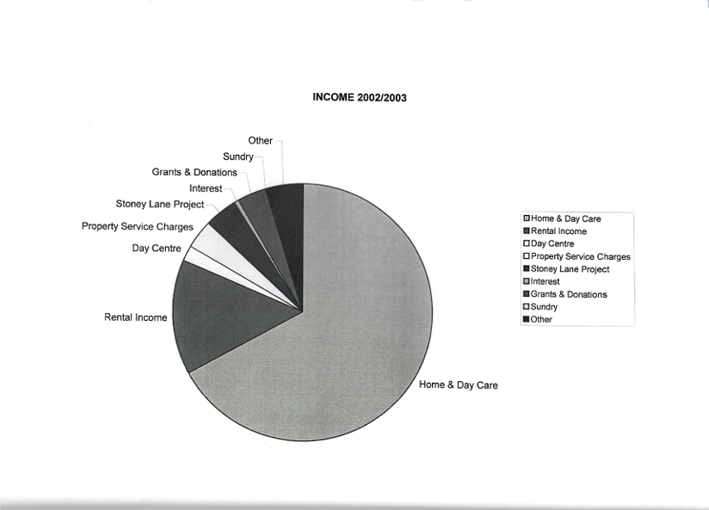

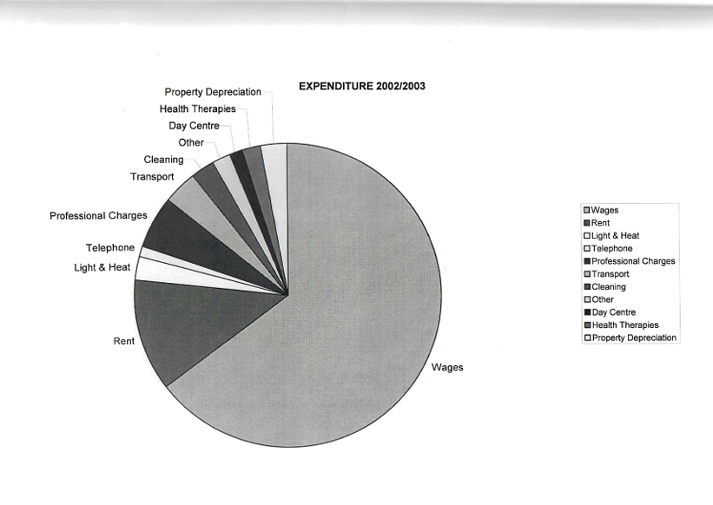

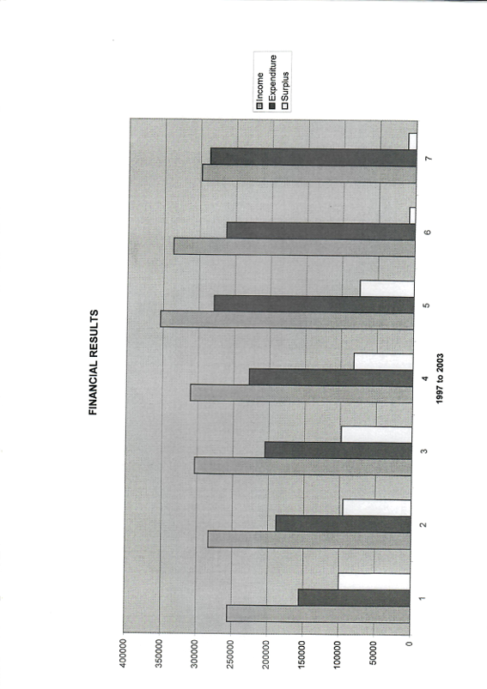

**SMETHWICK ASRA LIMITED**

Report of the Members of the Board

**Year ended 31st March 2003**

The directors have pleasure in presenting their report and the financial statements of the charity for the year ended 31st March 2003

**PRINCIPAL ACTIVITY**

The Company is an incorporated entity and registered charity governed by its Memorandum and Articles of Association

The principal activity is the provision of appropriate housing, health and care services to all needy elderly, disabled and families, particularly but not exclusively of the Asian origin, in the West Midlands area. As an ancillary, assistance is also given on social, recreational and educational matters

**REVIEW OF ACTIVITIES**

The main policies adopted to achieve the aims of the company during the year ended 31st March 2003 have been by the provision of:

1. Day Care, mainly in association with local Social Services, for elderly and disabled at our Fenton Street Centre, including the provision of transportation as required.
2. Domiciliary Care, mainly in association with local Social Services, for elderly, disabled and those suffering from chronic illnesses.
3. In association with Sanctuary Housing the management of rental accommodation consisting of 20 category 1 sheltered flats and 10 family houses
4. The management of 19 flats in association with Sandwell Metropolitan Borough Council.
5. In addition to day care at our Fenton Street Centre, the provision of assisted bathing, health therapies, sensory therapies for elderly and young people with learning disabilities, chiropody, rehabilitation, mental health and exercise sessions for Asian women, facilities for conferences, seminars and training, and offices to other organisations. Some of the aforementioned provisions are provided in "partnership" with Oldbury and Smethwick Primary Care Trust, Sandwell Asian Family Support Services and AKASH (Asian Women's' Health Initiative).

Where necessary the directors have had assistance from qualified advisors and the Local Business Community

**Results**

The results for the year, and the charity's financial position at the end of the year are shown in the attached financial statements

**SMETHWICK ASRA LIMITED**

Report of the Members of the Board (Continued)

**Year ended 31st March 2003**

**The directors**

The directors who served the charity during the period were as follows:

Dr V K Jhanjee

Mr K S Johal Mr H J Patel

Mr A Sawant

On 26th June 2003 Mrs K Jagpal was appointed as a director.

The trustees, who are appointed by the directors are Dr V K Jhanjee and Mrs H P Sangha

**Responsibilities of the directors'**

Company law requires the directors to prepare financial statements for each financial year which give a true and fair view of the state of affairs of the charity at the end of the year and of the surplus or deficiency for the year then ended

In preparing those financial statements, the directors are required to select suitable accounting policies, as described on page 7, and then apply them on a consistent basis, making judgements and estimates that are prudent and reasonable. The directors must also prepare the financial statements on the going concern basis unless it is inappropriate to presume that the charity will continue in business.

The directors are responsible for keeping proper accounting records which disclose with reasonable accuracy at any time the financial position of the charity and to enable them to ensure that the financial statements comply with the Companies Act 1985. The directors are also responsible for safeguarding the assets of the charity and hence for taking reasonable steps for the prevention and detection of fraud and other irregularities.

**Auditors**

A resolution to re-appoint Garratt & Co as auditors for the ensuing year will be proposed at the annual general meeting in accordance with section 385 of the Companies Act 1985

Registered office: Signed on behalf of the directors

Asra Health and Social Care Centre

Fenton Street

Smethwick

West Midlands

B66 IHR

Dr V K Jhanjee (Chairman)

Approved by the directors on 31st July 2003

**SMETHWICK ASRA LIMITED**

Independent Auditors' Report to the Members

Year ended 31 March 2003

We have audited the financial statements on pages 5 to 11 which have been prepared under the historical cost convention and the accounting policies set out on page 7

**Respective responsibilities of the directors and the auditors**

The responsibilities of the directors (who also act as Directors for the charitable activities of the company) of the company for preparing the Report of the Members of the Board and the financial statements in accordance with applicable law and United Kingdom Accounting Standards are set out in the Statement of Director's Responsibilities on page 3 

Our responsibility is to audit the financial statements in accordance with relevant legal and regulatory requirements and United Kingdom Auditing Standards 

We report to you our opinion as to whether the financial statements give a true and fair view and are properly prepared in accordance with the Companies Act 1985 We also report to you if , in our opinion , the Report of the Members of the Board is not consistent with the financial statements , if the company has not kept proper accounting records , if we have not received all the information and explanations we require for our audit , or if information specified by law regarding directors' remuneration and transactions with the charity is not disclosed 

We read the Report of the Members of the Board and consider the implications for our report if we become aware of any apparent misstatements within it . Our responsibilities do not extend to any other information 

**Basis of audit opinion**

We conducted our audit in accordance with Auditing Standards issued by the Auditing Practices Board. An audit includes examination, on a test basis, of evidence relevant to the amounts and disclosures in the financial statements. It also includes an assessment of the significant estimates and judgements made in the preparation of the financial statements, and of whether the accounting policies are appropriate to the company's circumstances, consistently applied and adequately disclosed

We planned and performed our audit so as to obtain all the information and explanations which we considered necessary in order to provide us with sufficient evidence to give reasonable assurance that the financial statements are free from material misstatement, whether caused by fraud or other irregularity or error. In forming our opinion, we also evaluated the overall adequacy of the presentation of information in the financial statements

**Opinion**

In our opinion the financial statements give a true and fair view of the state of affairs of Smethwick Asra Limited as at 31 March 2003 and of its incoming resources and application of resources in the year then ended and have been properly prepared in accordance with the Companies Act 1985

|  |  |
| --- | --- |
| 29 Waterloo Road | GARRATTS |
| Wolverhampton | Chartered Accountants |
| West Midlands | & Registered Auditors |

WI 4DJ

31stJuly 2003