Smethwick ASRA
ANNUAL REPORT 2004/05
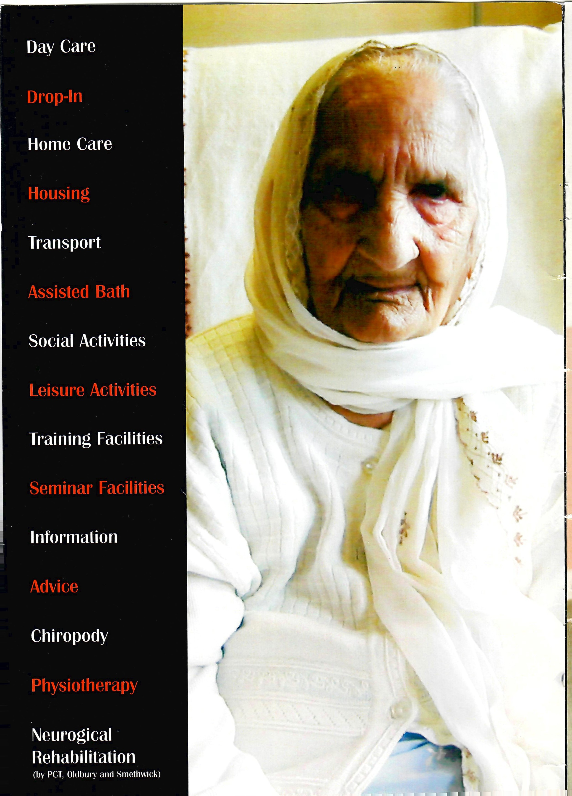
"Our task now is to continue the transformation right across the field of social care for adults so people are given more choice, high quality support and greater control over their lives. We need to ensure the services we deliver are flexible and responsive enough to meet the differing needs and wishes of individuals. We must build on what works and learn from the experience and knowledge of front-line staff. And we must continue investing in the workforce so they have the training and skills to deliver the services people want and deserve".
Rt Hon Tony Blair MP
The Prime Minister
From Independence, Well-being and Choice
our vision for the future of social care for adults in Enqland
SMETHWICK ASRA
ANNUAL VIEW/REPORT
2004/2005
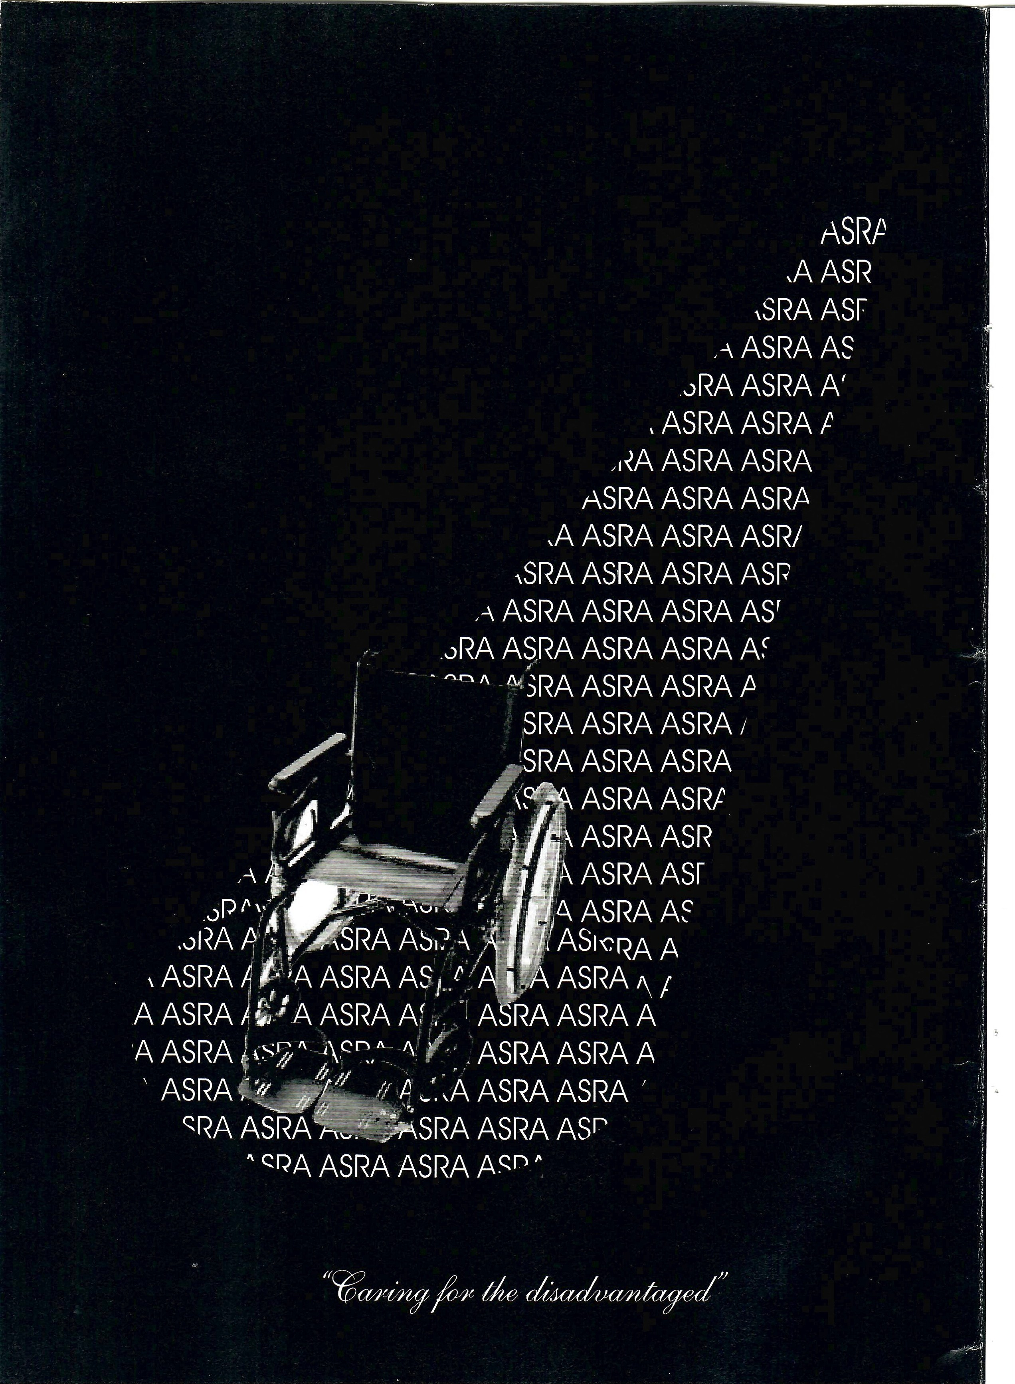
Contents
Page
Mission Statement 1
Annual Review 2
Jewels in the Crown 6
Asian Entrepreneurs in Britain
Smethwick AS RA 10
The Organisation
Legal & Admin Information Staff Members
Other Organisations at
ASRA Health and Social Care Centre 19
Financial Information 22

Mission Statement
We are committed to the provision of appropriate housing and care services for all the South Asian elderly, disabled and families
Annual Review 2004-05

Dr Viney Jhanjee, Chair of ASRA and Javed Parvez Projects
Director, review the year
2004 has been a very encouraging, busy and satisfactory year with soundly based progress and achievements, which we confidently expect to continue.
Instead of blue-sky thinking we have focussed on things which are more pragmatic and near to our market by implementing several key decisions to prepare us for facing future challenges from a strong position thereby ensuring that we make a significant difference in the lives of a greater number of Asian elderly and disabled.
The Asian family is undergoing great changes. Although these changes differ from community to community, there are some commonalities, smaller nuclear families, an increase in divorces, the greater longevity of family members, increase in single households, social and economic mobility by the younger members and the transformation of relationships due to changes in values. So please forget the myth that "they look after their own" and consign it to the waste bin of history.
Clearly much remains to be done to find effective ways to support the Asian elderly and the disabled. Effort by researchers, policy makers, other service providers and the Asian community itself is needed. In this period of profound technological advances and unprecedented change, the elderly supports of the past are insufficient for meeting the needs of the present. Action on the personal, local and national levels to make elderly wellness a priority needs to be encouraged.
We would urge Social Care Commissioning Managers to take into account the specialist nature of services provided by ASRA which are a great benefit to the Asian elderly and disabled.
It is clear that the demand for health and social care will increase as the Asian population ages. The biggest challenge over the next decade will be how this is funded. In our quite way we are working on attracting resources from national agencies so that some of the financial pressures are taken off the local authorities, at least in the short-terms who commission day care services.
In the year 2004-05 there has been a significant organisational change. The expansion of the Management Committee from seven committee members to twelve. Has been achieved .has been successful in attracting individuals with backgrounds and experience in housing, health, businesses, finance, community development and voluntary sector management. We now have individual representation from almost all sections of the Asian community. A balanced and capable Management Committee with both old and new members actively contributing to the strategic management of ASRA.
Once again this year people management continued to be a key priority for us. By allowing our staff the opportunities to gain and improve their skills, we are aiming to enable our workforce to bridge the gap between what they are and what they have it within themselves to become.
A new NVQ level 2 in direct care with South Staffordshire Training Association and Train to Gain., will address a critical gap and create an opportunity to boost the training and skills development for ten of our care workers.
In 2004 we submitted applications worth El 35,000 for funds to a number of national agencies. So far grants of E64,500 have been confirmed.
Since the year-end we have also purchased a new mobility minibus worth nearly E25,000
During 2005 we aim to use every opportunity to seek additional sources of funding to finance our development plans and supplement our services. We intend to embark on a fundraising campaign to seek money from local and national sources, other charities & trusts, private companies and individuals. In the next five years we seek to raise three million pounds towards our new projects/development.
We have been grant aided by the Tudor Trust for a two-year service development project. We aim to replicate the current successful Sandwell model of health and social care provision in Birmingham and Dudley.
Early this year we were also successful in attracting a grant from the department of Transport to develop two publications of a road safety magazine in English, also translated in Punjabi & Urdu. The main aim is to use it as a marketing tool to generate awareness of road safety issues. This project will be carried out in partnership with Sandwell Road Safety.
To reach our objectives, which are rightly ambitious, we have strong community support, a dedicated Management Team and can count on the constant efforts of our employees and volunteers, to whom the Board of Directors offers its unequivocal support for meeting future challenges.
We warmly acknowledge the help of Sandwell Social Inclusion and health, Harborne Parish Lands Charity, Henry Smith Charity, The Tudor Trust, Smethwick Town Committee, Help the Aged and
Department of Transport for their financial and technical support.
We would like to thank Amirk Nagra and his team for carrying out internal painting, regular and emergency repairs at very charitable rates, Mohammed Saeed of A.S. Electrical Contractors, Roger Quinton for preparing the Annual Accounts and Hans Raj of Garratts for organising the audit within six weeks of the end of the financial year.
Finally as Chairman of ASRA I wish to express my appreciation and I am certain that it reflects the unanimous feelings of the Board of Directors, for the work performed by our vice- chair Ali Sawant. His vision for waging an innovative and quality project, his fairness and tenacity for maintaining the independence and ensuring the development of ASRA, remains one of our most fundamental assets. His stance and selflessness as he gives up the Vice-Chairmanship of ASRA, represents an admirable example of generosity.

Thank you very much Ali Swant
Similarly through the years I have been fortunate to have been associated with a talented and committed body of people who have served as committee members that have been active in driving developments forward at ASRA. I would like to thank each and every one of them.

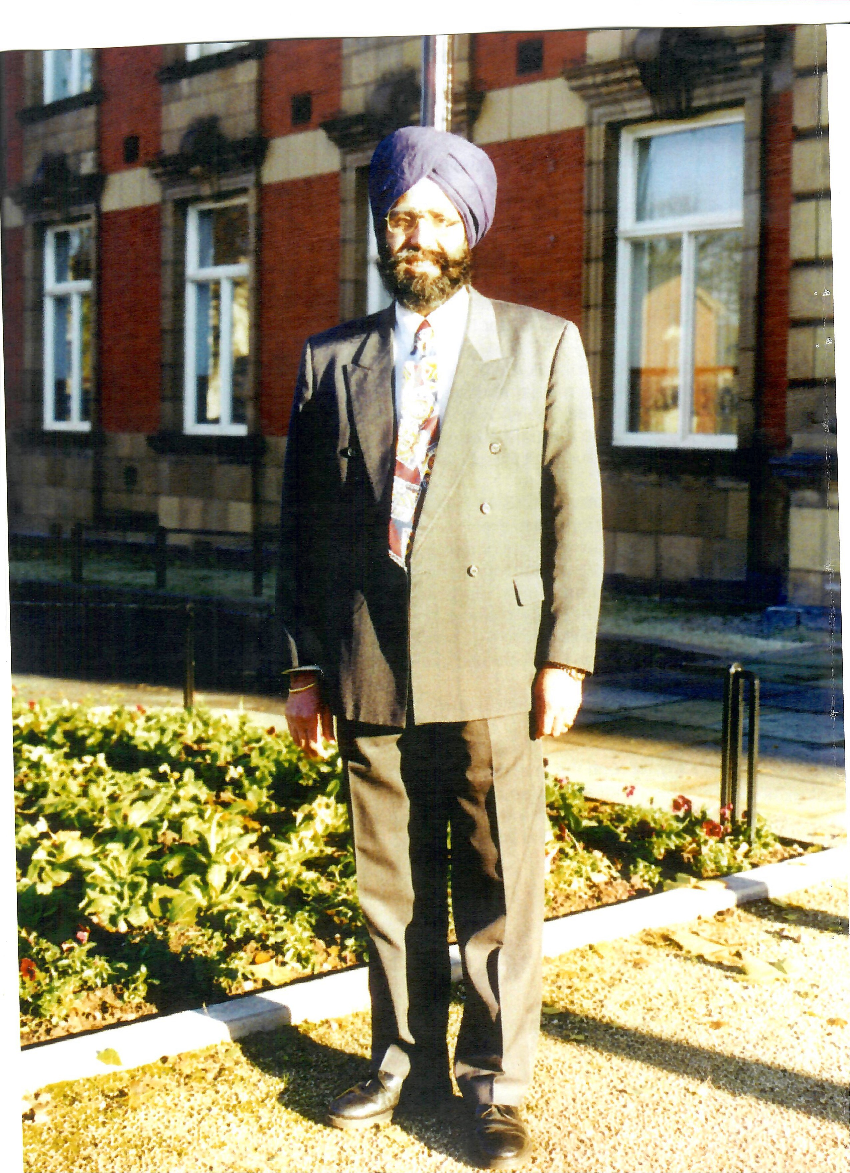

Jewels in the Crown
Asian Entrepreneurs in Britain
Celebrating Achievement and Success
If you want new and old economy wealth, if you want modern and traditional practices, if you want a new generation of wealth creators look at the list of Britain's top Asian entrepreneurs. The phenomenon contains tales of rags to riches many of them going much deeper than that, complexity of communities that, on some levels, are fully incorporated into their host societies and, on others, remain separate. Both prejudice and pride plays a part in these success stories. These are real financial and non financial triumphs and we should not be slow or quiet or reticent about telling the world and celebrating them.
From the shopkeeper and the restaurateur to the steel magnate and the pharmaceutical tycoon, these dynamic, determined individuals not only laid the foundations for Britain's Asian community, but also raised the bar of success for the future generations.
Asian wealth creates and sustains more jobs than it has ever done. It stimulates growth in industries and places that will struggle without the engine of Asian entrepreneurship. The wealth created is diversifying and modernising. It crosses the generational divide.
The success stories praise the grit and the determination that have gone into their staggering achievements. But at one point in their uphill climb, every single entrepreneur would have faced some form of prejudice, and would have had to have worked that much harder to clinch that deal, win that client or simply get that job. It is important not to forget this as we make inroads into other sectors of British life.

Amar Singh Editor, Eastern Eye/Dr Spinder Dhaliwal Associate Editor of Britain's Richest Asians 2004
 | Britain's Top 20 Asian Entrepreneurs
1 ^{st} | Mike Jatania & family - Lornamead - Cosmetics & Beauty Products (E600 million)
The rise of the Jatania family proves the strength and potential of the Asian family business beyond any doubt. Development of the company has come through a combination of business intellect, entrepreneurial sprit and aggressive and imaginative series of acquisitions. Lornamead has become a multinational brand owner and acquisitions have been made from, among others, Unilever, Sara Lee, Bristol-Myers, Squibb and Henkel Schwarzkopf.
2 ^{nd} | Vijay & Bhikhu Patel — Waymade Healthcare — Pharmaceuticals (450 million)
There is truly a rag — to - riches story. In 1975 with a loan, Vijay opened his first pharmacy and now, 30 years later, is the head of the co mpany Waymade Healthcare. It employs 700 people with a turnover of almost E300 Million. Their target is to create an Asian Glaxo.
3rd | Gulu Lalvani — Binatone — Electronics (E400 million)
Arriving as a student in the U.K in the 1960's, he made his first fortune from the pearl business. Over 40 years he created Binatone with his brother. Binatone now is an international customer electronics group with operations in the UK, Hong Kong and Germany.
4th | Tom Singh — New Look — Fashion (375 million)
Tom Singh borrowed E5,000 from his parents to open his first shop and has built the business up so that New Look is now a true high street giant and the third — biggest Womens'wear retailer in the Country.
5th | Jasminder Singh & Family — Edwardian Radisson Group Ltd — Hotels (350
Jasminder Singh and his family trusts own 86% in the Edwardian Radisson Group Ltd - one of the UK's leading and most successful hotel chains. In August 2004, the group opened its first hotel in Mayfair, London, with the E 115 - million purchase of an existing property.
^{6th} Lord Swarj Paul & Family — Caparo — Steel & Other Metals (E275 million)
Baron Paul of Marylebone is a leading businessman and one of the most active members of House of Lords, Lord Paul remains chairman of Caparo which has had an exceptional year.
The Sachdev family have seen the continuous growth and success of Life Style Care PLC . A nursing / home operator with 22 care centres, with a further five under construction, which will come on board in 2005 they employ more than 2, 000 people.
8th Sir Mohammed Anwar Pervez & Family – Bestway – Food distribution (£190 million)
7th Ramesh & Prathiba Sachdev- Sachdev Healthcare -Health care (£207 million)
He started his career as a bus conductor in Bradford. Now, 40 years after opening his first corner shop in London, his company Bestway Holdings, is one of the UK's biggest cash & carry businesses employing 4,250 people. He is the richest Asian Muslim in U.K
9th | Bharat & Ketan Mehta — Necessity Supplies - Pharmaceuticals — (£175 million)
The business now employs more than 200 people. Based in Uxbridge, the brother's fortune is the result of their business, Necessity Supplies which specialises in parallel importing.
10th | Firoz Kassam — London Park Hotel — Hotels & Leisure (£165 million)
Firoz Kassam is one of the most dynamic and energetic of our Entrepreneurs and continues to grow from strength to strength. From a thriving hotel business with operations all over London, the business portfolio has gone through a process of what could be called 'related diversification'.
11 ^{th} | Dinesh Dhamija — Ebookers — Travel, IT (£120 million)
Cambridge Arts graduate started his meteoric rise in business with a small stall in west London cheap flights to budget travellers. First founded flightbookers in 1983 and than Ebookers in 1999, which grew into a company that was worth over E200 million. Last year Dinesh sold Ebookers to Cedant for E209 million.
12th | Navin and Varsha Engineer — Chemidex — Pharmaceuticals | (£115 million)
The company have more than 40 product lines which are primarily manufactured out of facilities in eastern Europe and the Far East, and sold in the US, Europe and the Far East. Chemidex sold their 14 strong pharmacy businesses in 1999 for an estimated figure of E 12 million.
13th Shami Ahmed & Family — Joe Bloggs — Fashion, Property, Finance (£112 million)
Shami is active in the retail sector and in the property sector, with the disposal of his stakes in
Moss Brothers and Woolworths, with each sale fetching an estimated E 10 million. In recent years, the fashion end of the business has been solidified and internationalised — the company now employs more than 2,000 people across the world.
14th Abdul Alimahomed & Family — Europackaging — Packaging million) | (£110
The Birmingham based company manufactures paper bags and plastic carrier bags. Euro Packaging has seen turnover and profits continue to improve and this, together with other property and assets, puts the company value at E 110 million.
15th | Rajan & Sanjay Kumar— Fashion (£105 million)
This Manchester-based business has grown into a multi —million pound fashion wear distribution empire, with offices in London, New York, Du sseldorf, Madrid and Hong Kong. They also have property worth an estimated El 05 million.

16th Sir Gulam Noon, MBE & Family — Noon Products — Food Production (El 00 million)
The company has a solid reputation in the food business supplying to Sainsbury, Waitrose and Morrisons. The company now has a turnover of El 00 million, making over 1.2 million ready meals a week out of three plants.
17th | Nat Puri - Melton Medes Group — Industry ( £98 million)
The firm became the basis of his business empire, now built on three main companies — Melton Medes, Blugit Holdings and Conder Structures — involved in packaging, paper, engineering, textiles and plastics and spanning Germany, China, Poland and Hungary.
18 | Harpal Matharu & Family — Global Grange — Hotels (£95 million)
Harpal Matharu is one of the top 20 hoteliers in the country with his Global Grange business. The 200-bed Holborn Grange hotel, converted from a Ministry of Defence building, is the latest London project from the company.
19 | Surinder Arora & Family — Arora Hotel Group — Hotels (£90 million)
Surinder Arora opened the Arora International at Heathrow in 1999. It has won a contract to build a 600-room hotel at Heathrow Airport's new Terminal 5. His other hotels also include a 141 —bedroom operation in Manchester, which was developed in partnership with singer Sir Cliff Richard.
20th | Gurchait & Gurnaik Chima — Bon Marche Holdings — Fashion (£85 million)
The company has been established for over 20 years and now has 260 stores.

Smethwick ASRA — The Organisation
Smethwick Asian Sheltered and Residential Association (ASRA) is a Community
Organisation, a Charitable Association (Charity No 519620) and a Limited Company by Guarantee (Reg No. 2173760). ASRA was set up by a group of professionals and lay people concerned about the difficulties being faced by the South Asian elders and disabled in Sandwell.
The organisation promotes the relief of poverty, hardship and distress by providing housing, domiciliary care, day care and transport services to South Asian elders who are experiencing personal, social, health and family problems.
The primary objectives of ASRA are:
(i) The relief of poverty, hardship and distress by providing and maintaining accommodation for particularly elderly people (of south Asian origin or descent) residing in Smethwick and neighbourhoods thereof who are experiencing personal housing, health, and social care difficulties.
 The maintenance improvement and advancement of the vocational and occupational training of such elderly people.
(iii) To establish, furnish, alter, maintain and equip any residential accommodation including the management of such property whether principal or agent and also on behalf of a housing association.

Further Organisational Objectives
The specific objectives of the organisation have been defined as:
- To become a major care service provider for Asian elderly and disabled.
- To encourage Asian elderly and disabled to take advantage of community care provision.
- To develop care plans for Asian elderly and disabled clients on an individual basis.
- To provide sheltered housing, care services and transport services for Asian elderly and disabled.
- To promote & greater awareness of the housing and care needs of Asian elders and disabled in Sandwell.
- To undertake special need projects in partnership with Sandwell Housing, Social Services and Health Departments under the Community Care Legislation and Local Plans.

Services
ASRA takes pride in the fact that it provides services to all sections of the Asian community. Service provision is needs led and user controlled. Services are tailored to the individual's needs and the service delivery and staffing takes into account the main religious, cultural and national variations.
Day care services for Asian elderly and disabled, caters for their linguistic, cultural, dietary, religious, spiritual and social needs. Services at ASRA is based on trust, warmth and understanding. We provide caring, comfortable and a stimulating environment in which the service user pursue their interests with assistance from experienced care workers.
They also participate in other educational and recreational activities such as information seminars, reading Asian newspapers, books, sewing, knitting, drawing, painting, card games, bingo and reminiscence sessions.
Asian satellite channel ( Zee TV), Asian videos and Asian music are available for user's entertainment. A small library is also provided by Sandwell library services.

Domiciliary Care
ASRA provides a culturally and religiously sensitive home care service for Asian elderly and disabled that need care and support. We domiciliary cater for their individual needs, taking into account the users dignity, choice and independence. The service/care package is designed in partnership with users, their carers, families and statutory agencies. This service is provided seven days a week.

Housing
ASRA provides housing for Asian and other communities in Smethwick. Current accommodation consists of self-contained flats for the elderly and houses for families.

ASRA Health & Social Care Centre
This centre with the vision of providing health and social care with associated services for the local community and in particular Asian elderly was built in 1999. It has now become a community hub. The range of services within the centre has expanded considerably in the ensuing years.
The aim of providing health services in a non-NHS setting has been achieved. Services provided include: day care with rehabilitation, assisted bathing with hydrotherapy, social & leisure activities, training & seminar facilities, information & advice and drop-in.
Both voluntary and statutory agencies have been brought together to provide services, particularly but not exclusively to the Asian community. Asian Family Support Services, Primary Care Rehabilitation Team, Chiropody/Podi atry Services, Elderly Co-ordinators, The Sandwell South Asian Targeted Health Initiative (SSATHI) and South Asian Health Projects are the other organisations based at the centre.
In addition many community, voluntary, statutory organisations as well as individuals are making use of the conference room.
Care service for Asian elderly and disabled has been developed not only for their linguistic, cultural, dietary and religious needs, but also the views of their carers and families in mind. These services are greatly helping to alleviate some of the physical and mental manifestations of illness.

SMETHWICK ASRA
Legal and Administration Information

Manaqement Board/Committee
Lord King of West Bromwich - | Patron
Dr. Viney Jhanjee | Trustee/Chair
Mrs Paula Sangha | Trustee
Mr. Ali Sawant | Vice-Chair
Dr. Nitti Pall | Secretary
Mr. NarinderAurora | Treasurer
Mr. Kulwant Johal | Director
Mrs. Kalmit Jagpal | Director
Mr Khurshid Ahmed | Mr. Jagwant Gill
Mr. Mohammad Salim | Mr Monim Khan
Mr Matthew Shinda | Mr Sarwan Ghatora
Auditors
Garratts
Chartered Accountants & Registered Auditors
20 Waterloo Road
Wolverhampton
West Midlands

WVI 4DJ Bankers
Lloyds TSB Bank PLC
22A Great Hampton Street
Birmingham 813 6AH
Solicitors
Adcocks
Crossroads House
17-19 St. Michaels Street
West Bromwich
B70 7AB
Registered Office
ASRA Health and Social Care Centre
Fenton Street
Smethwick
West Midlands

B66 IHR
Registered Charity No: 519620
Registered Company No: 2173760
Constitution:
ASRA is a company limited by guarantee and a Registered charity, governed by its Memorandum and Articles of Association.
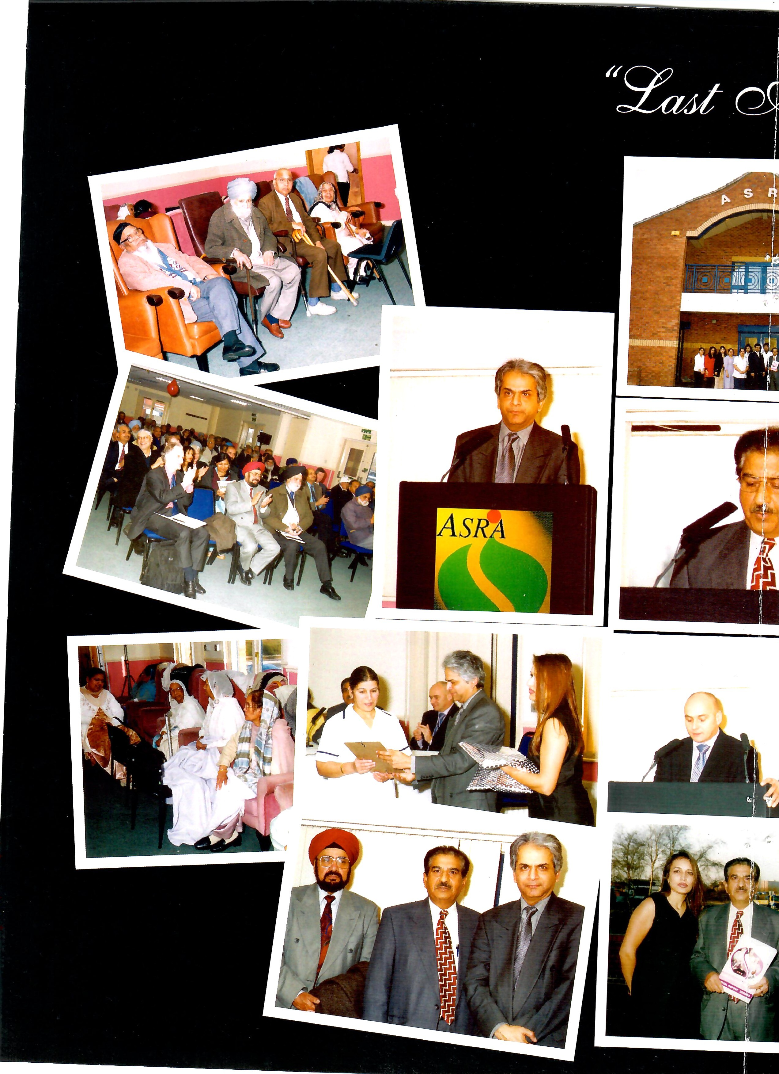

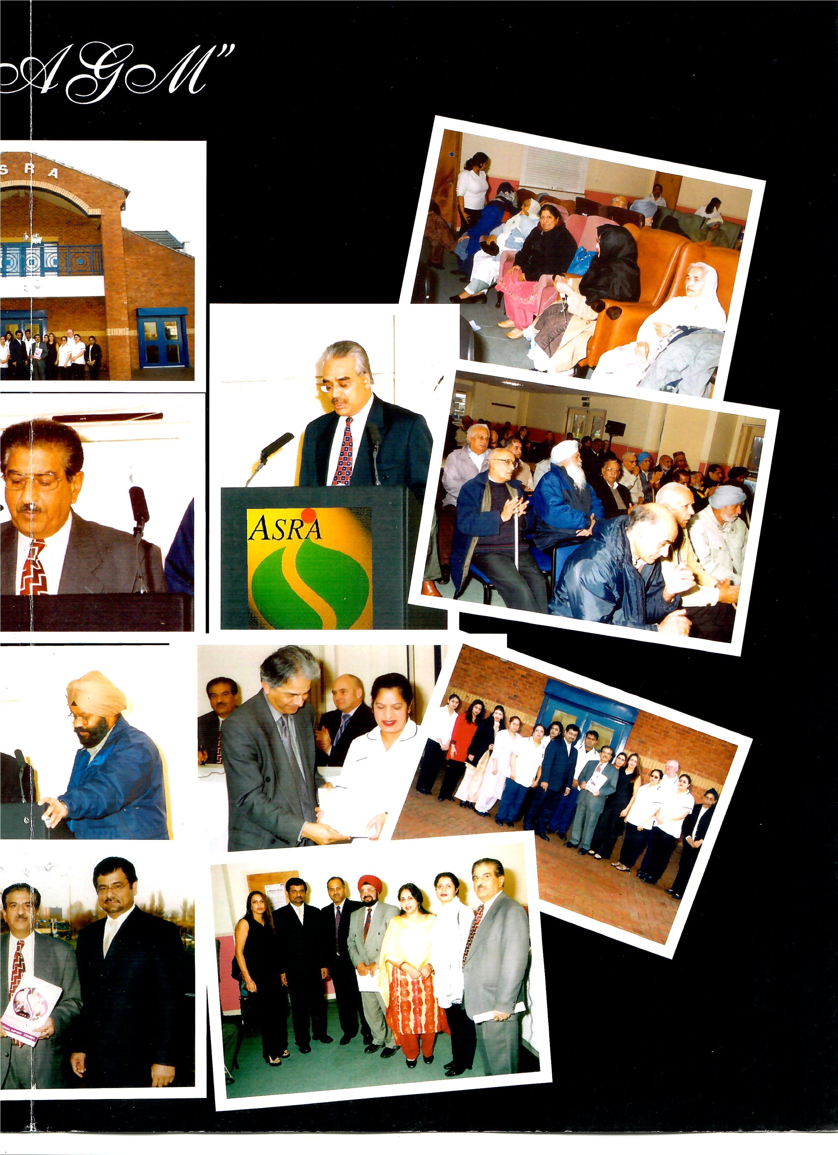

Mr. Javed Parvez  Mrs. Parvinder Shoker  Miss. Ruqayya Fatima Ali  Mrs. Rajinder Panesar  Mrs. Ravinder Panesar  Mr. Samuel Paul  Sarbjit Dhaliwal  Baljit Johal  Farida Begum  Baldish Bains  Randeep Kaur  Surinder Paul  Shahida Sultana  David Corlett  Usha Patel  Surjit Sidhu  Santokh Kaur  Elizabeth Shinda  Neeta Sharif  Gurbax Khalsi  Jasvinder Chana Babita Sharma  Mohammed Latif  Amandeep Singh Parmjeet Ghuman  Sukhjit Nagra | Projects Director  Care Manager  Administration  Assistant  Care Co-ordinator  Senior Care Worker  Senior Care Worker Care Worker  Care Worker  Care Worker  Care Worker  Care Worker  Care Worker  Care Worker  Care Worker Care Worker  Care Worker  Care Worker Care Worker  Care Worker  Care Worker  Care Worker  Care Worker Driver  Driver  Cook  General Assistant

Salma Jabeen  Shaube Himdi  Sonia Duttu | Jasvir Chahal  Islam Durrani  Jatinder Bal

Other Organisations/Services at
ASRA Health and social care Centre
Sandwell Asian Family Support Service
SAFSS provides a wide range of comprehensive and confidential services, which includes:
º Parents Carers Support Group Project - supports parents and carers, through group activities & one to one sessions.
Liaison Work - provides benefits, advice and emotional support to all families who have had a child or young person with disabilities.
Adults with Disabilities Project - provides one to one support and/or group work with adults aged between 18-30 years.
Short breaks for Asian Carers - provides a short break/respite care to carers who have an adult with a disability aged between 18 and 30 years.
Care at Home Service provides practical care in the home for children aged 0-18 years.
After School Club - provides an after-school facility, on weekdays and at the weekend.
For further information telephone on: 0121 558 2198

Chiropody/Podiatry Service
The Chiropody department set up a community clinic at ASRA in July 2000. This was to benefit the local community, in particularly Asian community members who had difficulty communicating in English would have on site interpreters. In the Asian community a high preference are diabetic and the knowledge of their condition is of great importance. Advice leaflets in Punjabi, Urdu and Bengali have been printed to help patients understand that care of their feet is paramount with their condition.

Primary care Rehabilitation Team
The Primary Care Rehabilitation Team (P CRT) provides an interdisciplinary rehabilitation service with staff drawn from a wide range of professions including: Physiotherapy, Occupational Therapy, Speech and Language Therapy, Specialist Nursing, Podiatry, Dietetics, Social Work, Clinical
Psychology and Counselling & Rehabilitation Support Worker.
The PCRT provides a client centred approach to rehabilitation.
A range of complementary services dependent on clinical need e.g. exercise programmes to improve or maintain mobility, dietary advice, advice on swallowing problems, medication information, work on practical difficulties in daily life etc.

Sandwell South Asian Targeted Health Initiative
The Sandwell South Asian Targeted Health Initiative (SSATHI) is a Sandwell Pan PCT funded health project. The aim of the project is to address health inequality within South Asian Communities in innovative ways. The project additionally seeks to draw on the experiences of clients in contributing to the development of policy and practice. It is a borough wide initiative, which operates in collaboration, and partnership with community based organisations and the Community Health Network to provide complimentary services. Some of the services provided over the last year included:
A Mental Health Support Group for women.
Comprehensive Health Programme in a variety of borough wide community based organisation and places of worship.
Innovative, Needs Led Structured Education for individuals with Type 2 Diabetes courtesy of funding from the Smethwick Neighbourhood Renewal Fund
A Cervical Screening and Breast Awareness Programme
Targeted Health Promotion work with men of the ASRA
A Bangladeshi Men's Health and Advice Project
Support to Health Visitors from a range of Health Centres
Advice, Support and Advocacy has been integrated in services that are delivered in the community in order to provide holistic services.
All services take culture, religion and linguistic differences into account. For more information contact the SSATH I projects on 533-2142 Or e-mail to southasian@proiects.wanadoo.co.uk

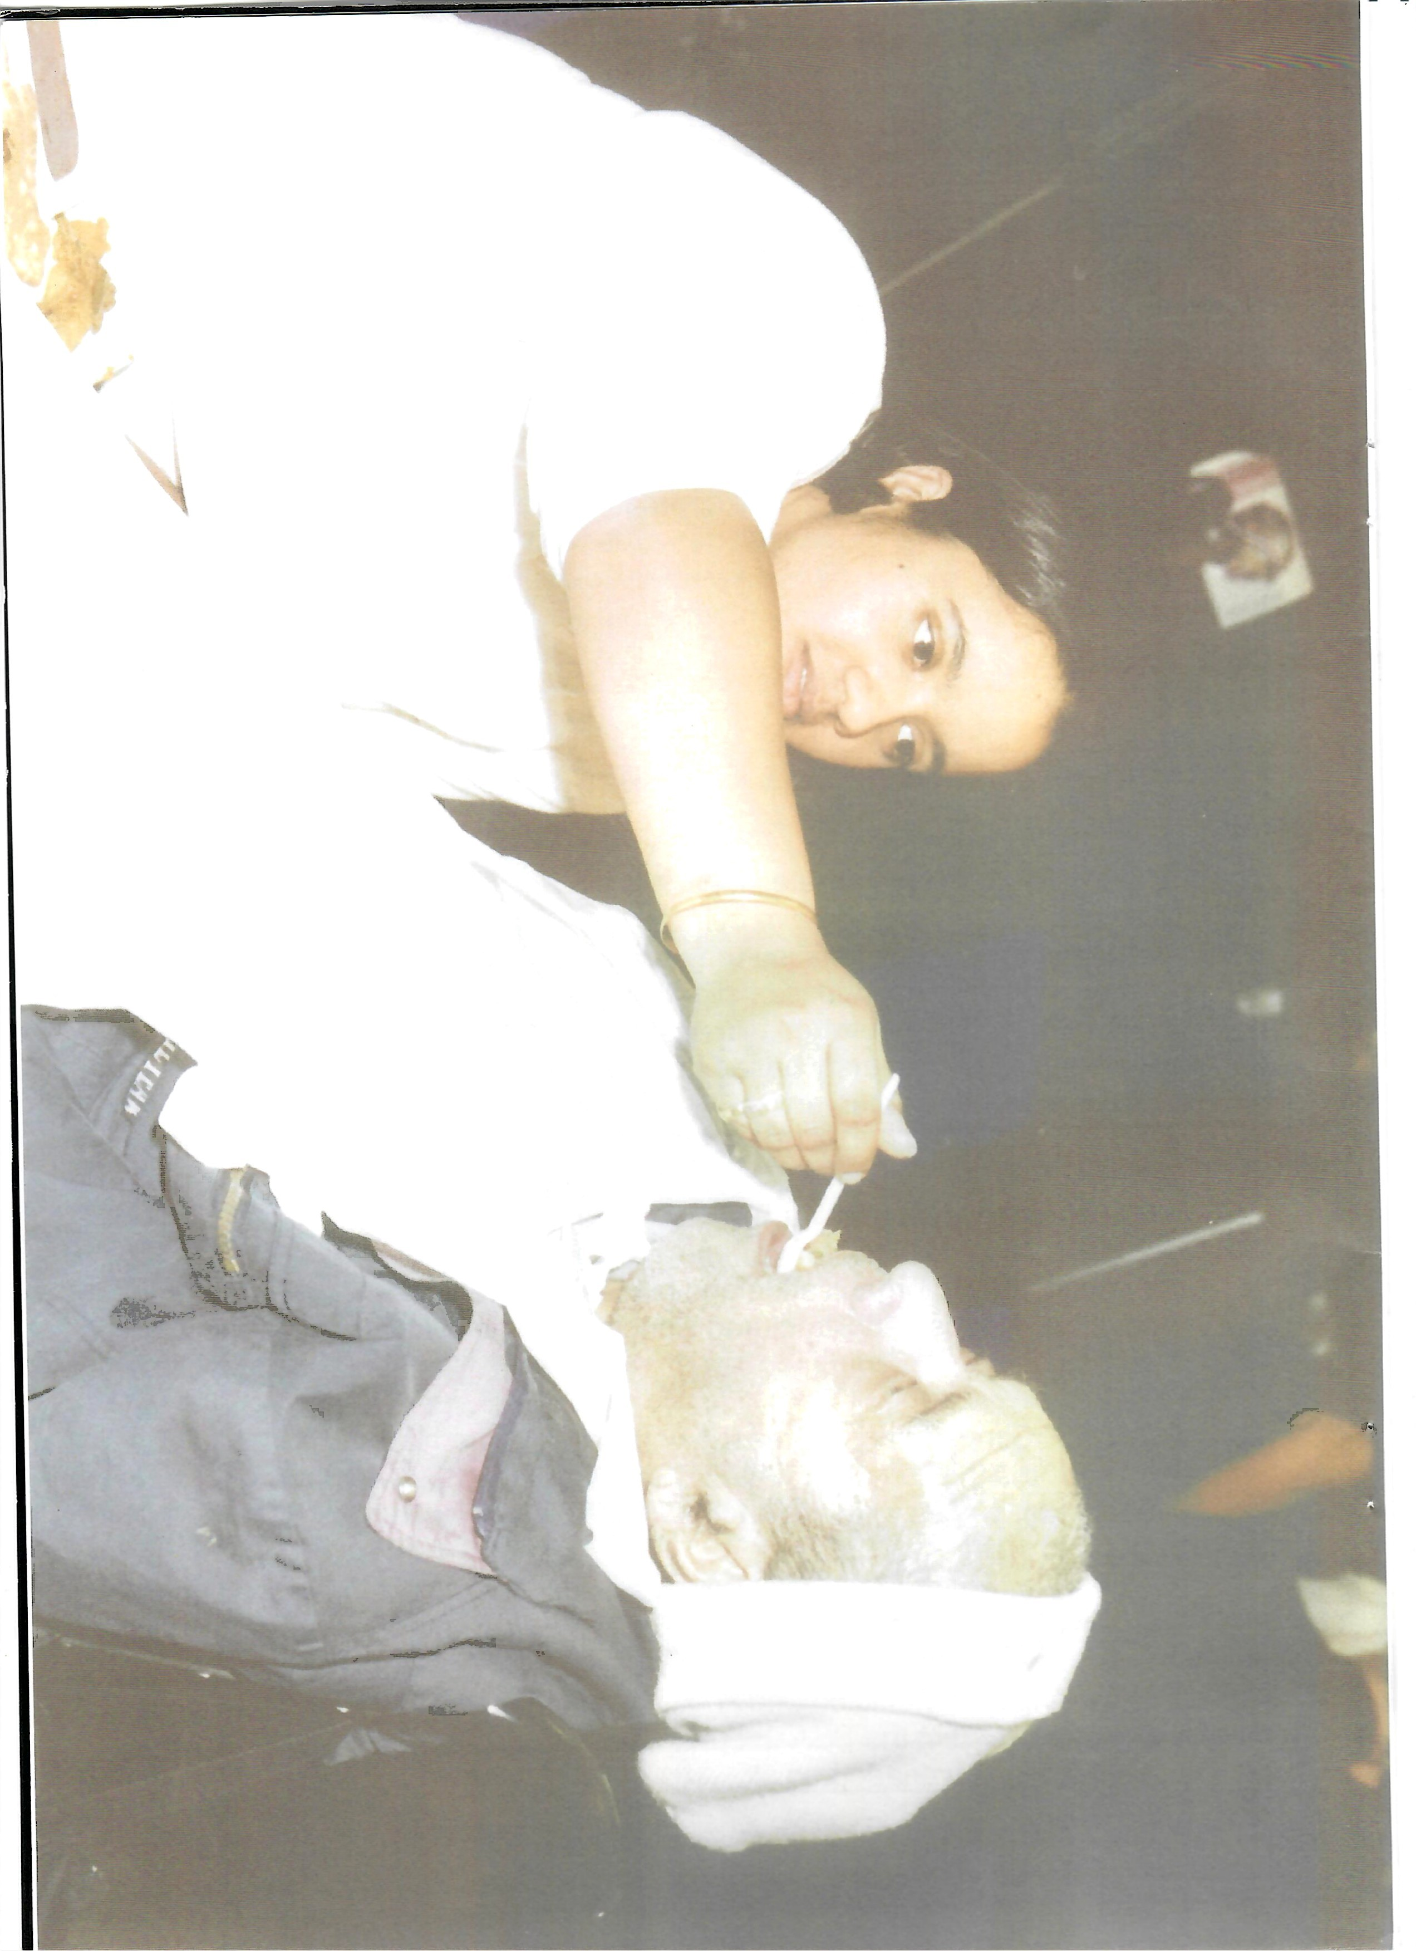

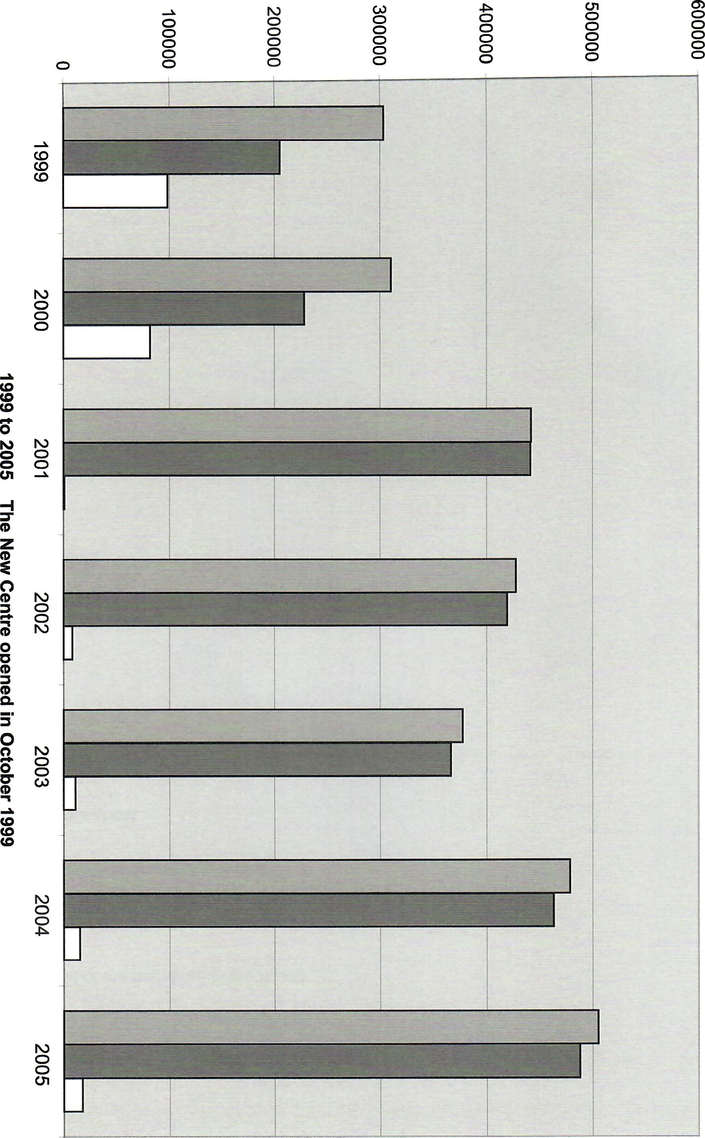
口
口
口
Financial Statements
Year ended 31st March 2005
Contents Pages
Report of the members of the board
Auditors' report to the members 3
Statement of financial activities 4
Balance sheet 5
Notes to the financial statements 6 to 10
Report of the Members of the Board
Year ended 31st March 2005
The directors have pleasure in presenting their report and the financial statements of the charity for the year ended 31st March 2005.
Principal activity
The Company is an incorporated entity and registered charity governed by its Memorandum and Articles of Association.
The principal activity is the provision of appropriate housing, health and care services to all needy elderly, disabled and families, particularly but not exclusively of the Asian origin, in the West Midlands area. As an ancillary, assistance is also given on social, recreational and educational matters.
Review of activities
The main policies adopted to achieve the aims of the company during the year ended 31st March 2005 have been by the provision of:
- Day Care, mainly in association with Social Services, for elderly and disabled at our Fenton Street Centre, including the provision of transportation, meals, social activities, assisted bathing, health therapies, sensory therapies, exercise sessions, chiropody and rehabilitation. The latter two provisions are provided in "partnership" with Oldbury and Smethwick Primary Care Trust.
- Domiciliary Care, mainly in association with Social Services, for elderly, disabled and those suffering from chronic illnesses. The Company is registered with the Commission for Social Care Inspection under the Care Standards Act 2000.
- In association with Sanctuary Housing the management of rental accommodation consisting of twenty category 1 sheltered flats and ten family houses.
- The management of sixteen flats in association with Sandwell Metropolitan Borough Council.
- The rental of offices and associated facilities to Smethwick Primary Care Trust, Sandwell Asian Family Support Services and South Asian Projects.
- Facilities for conferences, seminars and training meetings to both statutory and voluntary organisations.
- Facilities for community and private social functions.
The company is actively pursuing the extension of Day Care provision to the neighbouring geographical areas of Birmingham and Dudley.
Where necessary the directors have had assistance from qualified advisors and the Local Business Community.
Results
The results for the year, and the charity's financial position at the end of the year are shown in the attached financial statements.

Report of the Members of the Board (Continued)
Year ended 31st March 2005
The directors
The directors who served the Company throughout the period, unless otherwise stated, were as follows:
Dr V K Jhanjee
Mrs K Jagpal
Mr KS Johal
Mr A Sawant
The trustees for the charitable activities of the Company are the directors.
Responsibilities of the directors'
Company law requires the directors to prepare financial statements for each financial year which give a true and fair view of the state of affairs of the charity at the end of the year and of the surplus or deficiency for the year then ended.
In preparing those financial statements, the directors are required to select suitable accounting policies, as described on page 7, and then apply them on a consistent basis, making judgements and estimates that are prudent and reasonable. The directors must also prepare the financial statements on the going concern basis unless it is inappropriate to presume that the charity will continue in business.
The directors are responsible for keeping proper accounting records which disclose with reasonable accuracy at any time the financial position of the charity and to enable them to ensure that the financial statements comply with the Companies Act 1985. The directors are also responsible for safeguarding the assets of the charity and hence for taking reasonable steps for the prevention and detection of fraud and other irregularities.
Auditors
A resolution to re-appoint Garratts as auditors for the ensuing year will be proposed at the annual general meeting in accordance with section 385 of the Companies Act 1985.
Registered office: Signed on behalf of the directors
Asra Health and Social Care Centre
Fenton Street
Smethwick West Midlands B66 IHR
Dr V K Jhanjee ( Chairman )
Approved by the directors on DATE
Independent Auditors' Report to the Members
Year ended 31 March 2005
We have audited the financial statements on pages 5 to 11 which have been prepared under the historical cost convention and the accounting policies set out on page 7.
This report is made solely to the company's shareholders, as a body, in accordance with Section 235 of the Companies Act 1985. To the fullest extent permitted by law, we do not accept or assume responsibility to anyone other than the company and the company's board members and trustees for our audit work, for this report, or for the opinions we have formed.
Respective responsibilities of the directors and the auditors
The responsibilities of the directors ( who also act as trustees for the charitable activities of the company ) of the company for preparing the Report of the Members of the Board and the financial statements in accordance with applicable law and United Kingdom Accounting Standards are set out in the Statement of Director's Responsibilities on page 3
Our responsibility is to audit the financial statements in accordance with relevant legal and regulatory requirements and United Kingdom Auditing Standards
We report to you our opinion as to whether the financial statements give a true and fair view and are properly prepared in accordance with the Companies Act 1985 . We also report to you if , in our opinion , the Report of the Members of the Board is not consistent with the financial statements , if the company has not kept proper accounting records , if we have not received all the information and explanations we require for our audit , or if information specified by law regarding directors' remuneration and transactions with the charity is not disclosed
We read the Report of the Members of the Board and consider the implications for our report if we become aware of any apparent misstatements within it . Our responsibilities do not extend to any other information
Basis of audit opinion
We conducted our audit in accordance with Auditing Standards issued by the Auditing Practices Board. An audit includes examination, on a test basis, of evidence relevant to the amounts and disclosures in the financial statements. It also includes an assessment of the significant estimates and judgements made in the preparation of the financial statements, and of whether the accounting policies are appropriate to the company's circumstances, consistently applied and adequately disclosed.
We planned and performed our audit so as to obtain all the information and explanations which we considered necessary in order to provide us with sufficient evidence to give reasonable assurance that the financial statements are free from material misstatement, whether caused by fraud or other irregularity or error. In forming our opinion we also evaluated the overall adequacy of the presentation of information in the financial statements.
Opinion
In our opinion the financial statements give a true and fair view of the state of affairs of Smethwick Asra Limited as at 31 March 2005 and of its incoming resources and application of resources in the year then ended and have been properly prepared in accordance with the Companies Act 1985.

29 Waterloo Road GARRATTS
Wolverhampton Chartered Accountants
West Midlands & Registered Auditors
WVI 4DJ
24th May 2005

Statement of Financial Activities
Year ended 31st March 2005
 |  | Unrestricted | Restricted | Total Funds | Total Funds
Incoming resources  Donations, legacies and | Note | Funds | Funds | 2005 | 2004
similar incoming resources  Activities in furtherance of the | 2 | 40 |  | 40 | 76
charity's objects |  | 481 ,208 | 20,100 | 501 ,308 | 477,016
Interest receivable  Income from activities for |  | 2,271 |  | 2,271 | 941
generating funds |  | 1,614 |  | 1,614 | 345
Total incoming resources | 485,133 | 20,100 | 505,233 | 478,378
Resources expended
Direct charitable
expenditure  Management and | 3 | 378,492 | 14,100 | 392,592 | 375,564
administration | 4 | 95,105 |  | 95,105 | 87,574
Total resources expended | 5 | 473,597 | 14,100 | 487,697 | 463,138
Net incoming resources for the
year | 11 ,536 | 6,000 | 17,536 | 15,240
Balances brought forward | 449,478 |  | 449,478 | 434,238
Balances carried forward 461,014 6,000 467,014 449,478
The charity has no recognised gains or losses other than the results for the year as set out above.
All of the activities of the charity are classed as continuing. The notes on pages 7 to 11 form part of these financial statements

Balance Sheet
31st March 2005
Note 2005 2004
Fixed assets
Tangible assets 6 353,938 361 ,883
Current assets
Debtors | 7 | 38,504 | 89,887
Cash at bank and in hand |  | 131,575 | 64,539
 |  | 170,079 | 154,426
Creditors: Amounts falling due within one year | 8 | (57,003) | (66,831 )
Net current assets | 113,076 | 87,595
Net assets 467,014 449,478
Funds
Restricted 6,000
Unrestricted 461 ,014 449,478
467,014 449,478

These financial statements were approved by the directors on the 24th May 2005 and are signed on their behalf by: Dr V K Jhanjee (Chairman)
The notes on page 7 to 11 form part of these financial statements
Notes to the Financial Statements
Year ended 31st March 2005
1 Accounting policies a Basis of accounting
The financial statements have been prepared under the historical cost convention, and in accordance with applicable accounting standards and the Statement of Recommended Practice on accounting by charities.
- Grants - fixed assets
All grants received towards fixed assets have been netted off against the cost.
- Depreciation
Depreciation is calculated so as to write off the cost of an asset, less its estimated residual value, over the useful economic life of that asset as follows:
Long Leasehold Property - 2% per annum, straight line
- Non capitalised fixed assets
Capital expenditure is written off when acquired, with the exception of Long Leasehold Property.
Notional depreciation on non capitalised fixed assets expenditure is calculated in note 6 of the financial statements, to show the residual value of non capitalised assets at the balance sheet date.
- Income
Income represents all rents, capital grants relating to non-capitalised fixed assets, revenue grants and donations receivable during the period under review.
- Format of the accounts
In the opinion of the board of directors the format requirements of Schedule 4 of the Companies Act 1985 are inappropriate for this company. The board have adopted a format which they feel is more meaningful to the members and which is required to enable the financial statements to show a true and fair view.

- Grants receivable
2005 2004
Donations 40 76
- Direct charitable expenditure
 | Unrestricted | Restricted |  | Total Funds |  | Total Funds
 | Funds  Provision of charitable services: |  | Funds | 2005 |  | 2004
 | Charitable services 378,492  Analysis of provision of charitable services: |  | 14,100 | 392,592 |  | 375,564
 | Staff costs | Depreciation |  | Other costs | Total 2005 | Total 2004
4 | Charitable services 187,238  Management and administration | 7,945 |  | 197,409 | 392,592 | 375,564
 | Unrestricted |  | Restricted | Total Funds |  | Total Funds
 | Funds  Salaries 67,439 Office costs 4,997  Audit fees 2,644  Legal and professional 20,025 |  | Funds | 2005  67,439  4,997  2,644  20,025 |  | 2004  64,994  5,431  2,021  15,128
 |  | 95,105 | 95,105 87,574
5 | Total resources expended |  | Total Funds Total Funds
 | Staff costs  Direct charitable | Depreciation | Other costs 2005 2004
 | expenditure 187,238 Management and | 7,945 | 197,409 392,592 375,564
 | administration 67,439 |  | 27,666 95,105 87,574
254,677  The aggregate payroll costs were: | 7,945 | 225,075 | 487,697  2005 | 463,138  2004
Wages and salaries |  |  | 238,175 | 220,277
Social security costs |  |  | 16,502 | 16,549
254,677 236,826

- Total resources expended (continued)
Particulars of employees:
The average number of staff employed by the charity during the financial year amounted to:
 | 2005 | 2004
 | No. | No.
Care and Other Direct Workers | 22 | 19
Management and Administration | 3 | 3
No employees received emoluments of E50,000 or more during the year  Directors  None of the directors received any remuneration during the year (2004 - £nil) | 25 | 22
Other costs | 2005 | 2004
Premises | 51 ,930 | 54,659
Legal and Professional | 23,900 | 18,611
Other costs | 149,245 | 145,097
225,075 218,367
- Tangible fixed assets
Long leasehold property
Cost
At 1st April 2004 397,242
At 31st March 2005  Depreciation | 397,242
At 1st April 2004 | 35,359
Charge for the year | 7,945
At 31st March 2005  Net book value | 43,304
At 31st March 2005 | 353,938
At 31st March 2004 | 361 ,883
Cost is represented by total expenditure of E 805,722 less grants received of E 408,480.
6 Tangible fixed assets (continued)
Non capitalised fixed assets
 |  | Alterations | Fixtures
 |  | Leasehold | Fittings & | Office | Motor
Net Book Value: | Total | Buildings | Furniture | Equipment | Vehicles
At 31st March 2004 | 92,498 | 11,939 | 62,157 | 6,911 | 11,491
Additions | 3,341 |  | 3,173 | 168
Depreciation | (11,419) | (597) | (6,533) | (1 ,416) | (2,873)
 | At 31st March 2005  Depreciation Method | 84,420 11,342  - Reducing balance | 58,797 | 5,663 | 8,618
7 | Depreciation Rate  Debtors | 5% | 10% | 2005 | 25%  2004
 | Home and day care |  |  | 19,759 | 43,509
 | Rents etc receivable |  |  | 15,834 | 42,190
 | Other debtors |  |  | 196 | 849
 | Prepayments |  |  | 2,715 | 3,339
 |  | 38,504 | 89,887
8 | Creditors: Amounts falling due within one year
 |  | 2005 | 2004
 | PAYE and social security etc | 13,252 | 7,636
 | Sanctuary Housing re Stony Lane project | 24,530 | 48,410
 | Rent and rates | 8,056 | 1 ,007
 | Electricity and gas | 5,040
 | Telephone, printing, stationery and advertising | 376 | 1,917
 | Repairs | 250 | 904
 | Professional and development charges | 2,644 | 2,021
 | Non capitalised fixed assets | 1 ,260
 | Day centre costs etc | 1 ,595 | 903
57,003 66,831
9 Commitments under operating leases
At 31 March 2005 the charity had annual commitments under non-cancellable operating leases in respect of land and buildings which expire after more than five years of E14,500 (2004 - E 14,500).
- Capital commitments
As at 31st March 2005 the company had no capital commitments.
- Analysis of net assets in unrestricted funds
Tangible Other fixed assets net assets Total
Unrestricted funds 353,938 107,076 461 ,014
- Contingencies
There were no contingent liabilities at 31st March 2005
- Ultimate control
The company is controlled by the board of directors who are also the members of the company.
- Company limited by guarantee
Smethwick Asra Limited is a company limited by guarantee. In the event of a winding up or dissolution of the company, members liability under the memorandum of association is limited to El each.
At 31st March 2005 there were 4 members.

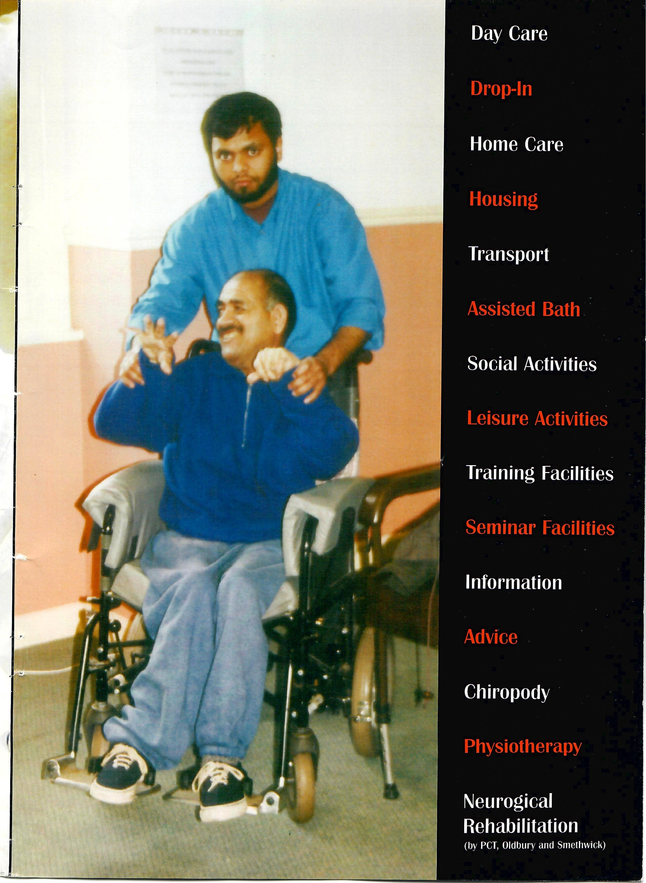

Smethwick ASRA
ASRA Health & Social Care Centre,
Fenton Street,
Smethwick,
B66 I HR
Print: Print Xpress - 0121 702 2225
T. 012 1 565 4678
F. 012 1 565 468 1
W www.smethwickasra.co.uk Charity No. 5 1 9620
E. info@smethwickasra.co.uk Reg in England 2 1 73760

